MODULE – 3

SE – Fundamentals of Programming

* Display This Information using printf

1) Your Name

2) Your Birth Date

3) Your Age

4) Your Address

INPUT

|  |
| --- |
| #include<stdio.h>  int main(){  printf("My name is NAMAN");  printf("\nMy Birth Date is 23 FEB");  printf("\nMy age is 20");  printf("\nMY City is Amreli");    return 0;  } |

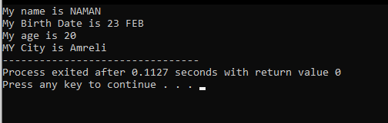OUTPUT

* Write a program to make Simple calculator (to make addition, subtraction, multiplication, division and modulo)

INPUT

|  |
| --- |
| #include<stdio.h>  int main(){  int n1,n2;  printf("Enter the num1 :");  scanf("%d",&n1);  printf("\nEnter the num2 :");  scanf("%d",&n2);    printf("\nAddition of %d and %d is : %d",n1,n2,n1+n2);  printf("\nSubtraction of %d and %d is : %d",n1,n2,n1-n2);  printf("\nMultiplication of %d and %d is : %d",n1,n2,n1*n2);  printf("\nDivision of %d and %d is : %d",n1,n2,n1/n2);  printf("\nModulo of %d and %d is : %d",n1,n2,n1%n2);  return 0;  } |

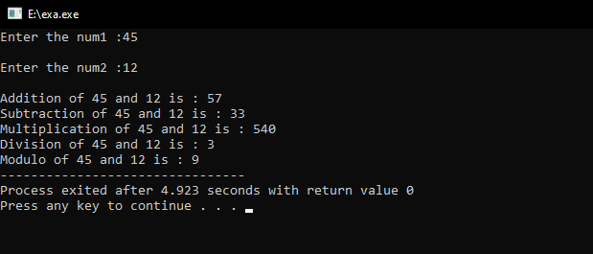 OUTPUT

* WAP to find area of circle, rectangle and triangle

INPUT

|  |
| --- |
| #include<stdio.h>  int main()  {  int r ,l,w,b,h;  double cirRes,TriRes;    printf("Enter the value of radius : ");  scanf("%d",&r);  cirRes = 3.14*r*r;  printf("\nThe area of circle is : %f",cirRes);  printf("\nEnter the value of length : ");  scanf("%d",&l);  printf("\nEnter the value of width : ");  scanf("%d",&w);  printf("\nThe area of Ractangle is : %d",w*l);  printf("\nEnter the value of Base : ");  scanf("%d",&b);  printf("\nEnter the value of height : ");  scanf("%d",&h);  TriRes = (h*b/2);  printf("\nThe are of Tringle is : %f",TriRes);  } |

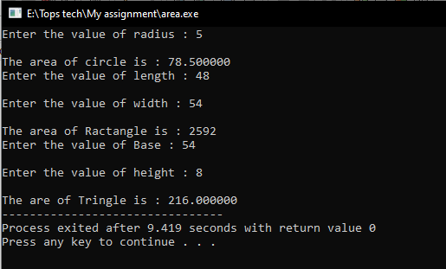OUTPUT

* WAP to find simple interest

INPUT

|  |
| --- |
| #include<stdio.h>  int main()  {  int a , r , y ;  double res;  printf("Enter the amount : ");  scanf("%d",&a);  printf("\nEnter the interest rate : ");  scanf("%d",&r);  printf("\nEnter the number of year : ");  scanf("%d",&y);  res = (a*r*y)/100;  printf("\nThe interest is : %f ",res);  } |

OUTPUT

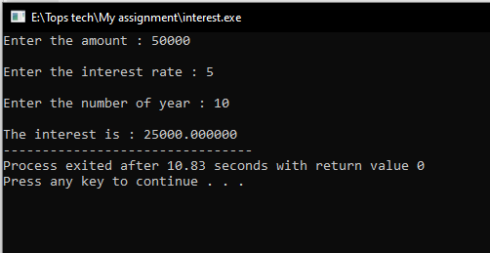

* WAP to check if the given year is a leap year or not.

INPUT

|  |
| --- |
| #include <stdio.h>  int main(){  int y;  printf("Enter the year to check: ");  scanf("%d",&y);  if (((y % 4 == 0) && (y % 100!= 0)) || (y%400 == 0))  printf("It is a leap year");  else  printf("It is not a leap year");  return 0;  } |

OUTPUT

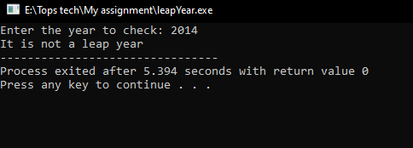

* WAP to convert years into days and days into years

INPUT

|  |
| --- |
| #include <stdio.h>  int main(){  int y,d;  printf("Enter the number of years : ");  scanf("%d",&y);  printf("\nTotal days is : %d",y*365);  printf("\n\nEnter the number of Day : ");  scanf("%d",&d);  printf("\nTotal days is : %d",d/365);  } |

OUTPUT

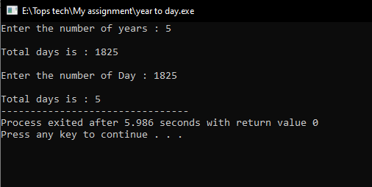

* WAP to swap two numbers without using third variable

INPUT

|  |
| --- |
| #include <stdio.h>  int main()  {  int n1,n2;  n1 = 50;  n2 = 20;  printf(" before swap value of n1 %d and n2 %d is",n1,n2);  n1 = n1+n2;  n2 = n1-n2;  n1 = n1-n2;  printf("\n\n after swap value of n1 %d and n2 %d is",n1,n2);    return 0;  } |

OUTPUT

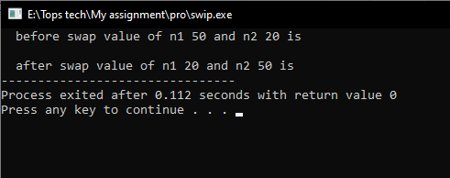

* WAP to find number is even or odd using ternary operator

INPUT

|  |
| --- |
| #include<stdio.h>  int main()  {  int a;  printf("Enter the Number : ");  scanf("%d",&a);  a%2 == 0 ? printf("\nThis is even ") : printf("\nThis is odd ");  } |

OUTPUT

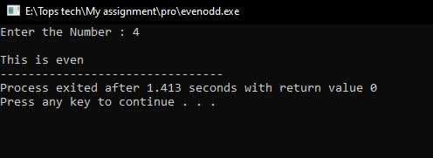

* WAP to show

1. Monday to Sunday using switch case

2. Vowel or Consonant using switch case

1) INPUT

|  |
| --- |
| #include<stdio.h>  int main()  {  int day;  printf("\nEnter a day:");  scanf("%d",&day);  switch(day)  {  case 1:  printf("\nMonday");  break;  case 2:  printf("\nTuesday");  break;  case 3:  printf("\nWednesday");  break;  case 4:  printf("\nThursday");  break;  case 5:  printf("\nFriday");  break;  case 6:  printf("\nSaturday");  break;  case 7:  printf("\nSunday");  break;  default :  printf("\nInvalid Input");  break;  }  return 0;  } |

OUTPUT

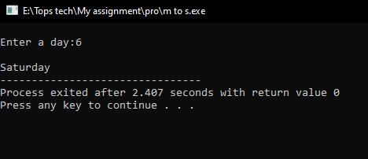

2 ) INPUT

|  |
| --- |
| #include <stdio.h>  int main()  {  char ch;  /* Input an alphabet from user */  printf("Enter any alphabet: ");  scanf("%c", &ch);  /* Switch value of ch */  switch(ch)  {  case 'a':  printf("Vowel");  break;  case 'e':  printf("Vowel");  break;  case 'i':  printf("Vowel");  break;  case 'o':  printf("Vowel");  break;  case 'u':  printf("Vowel");  break;  case 'A':  printf("Vowel");  break;  case 'E':  printf("Vowel");  break;  case 'I':  printf("Vowel");  break;  case 'O':  printf("Vowel");  break;  case 'U':  printf("Vowel");  break;  default:  printf("Consonant");  }  return 0;  } |

OUTPUT

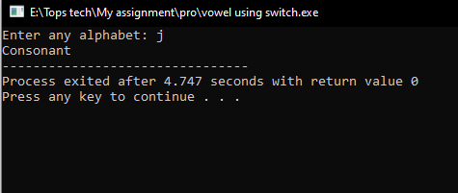

* Looping programs:

1. WAP to print 972 to 279 using for loop

2. WAP to take 10 no. Input from user and find out …

How many Even numbers are there

How many odd numbers are there

Sum of even numbers

Sum of odd numbers

3. WAP to print table up to given numbers

1 ) INPUT

|  |
| --- |
| #include <stdio.h>  int main(){  int num,r,sum=0,t;  printf("Input a number: ");  scanf("%d",&num);  for(t=num;num!=0;num=num/10){  r=num % 10;  sum=sum*10+r;  }  printf("The number in reverse order is : %d \n",sum);  } |

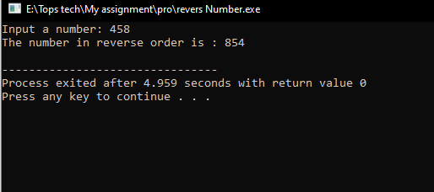OUTPUT

2 ) INPUT

|  |
| --- |
| #include<stdio.h>  int main()  {  int n,even = 0 , odd = 0 ,esum = 0 ,osum = 0;  for(int i = 1 ; i <= 10 ; i++)  {  printf("Enter the %d number : ",i);  scanf("%d",&n);  if(n%2==0)  {  even++;  esum = esum + n;  }  else  {  odd++;  osum = osum + n;  }  }  printf("\nTotal number of even is : %d",even);  printf("\nTotal number of odd is : %d",odd);  printf("\nAddition of all even number is : %d",esum);  printf("\nAddition of all odd number is : %d",osum);  } |

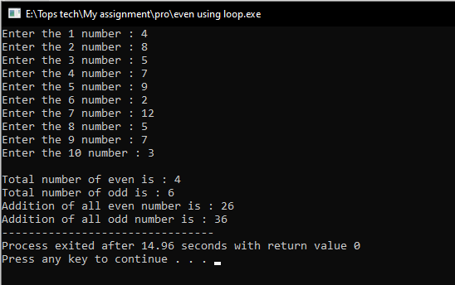OUTPUT

3 ) INPUT

|  |
| --- |
| #include<stdio.h>  int main()  {  int n;  printf("Enter the number : ");  scanf("%d",&n);  for(int j = 1 ; j <= n ; j++)  {  for(int i = 1 ; i <= 10 ; i++)  {  printf(" %d * %d = %d\n",j,i,j*i);  }  printf("\n\n");  }    } |

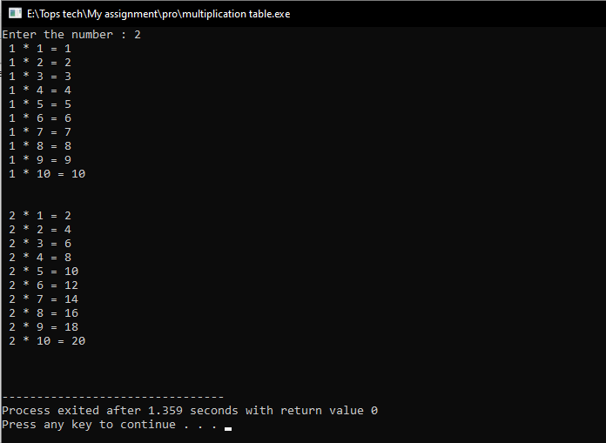OUTPUT

* WAP to print factorial of given number

INPUT

|  |
| --- |
| #include<stdio.h>  int main ()  {  int i,fact=1,number;  printf("Enter a number: ");  scanf("%d",&number);  for(i=1;i<=number;i++){  fact=fact*i;  }  printf("Factorial of %d is: %d",number,fact);  } |

OUTPUT

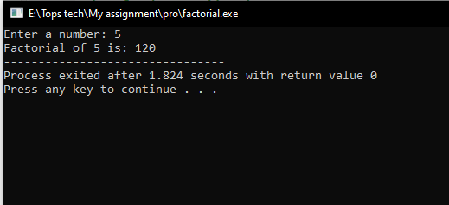

* WAP to print Fibonacci series up to given numbers

INPUT

|  |
| --- |
| #include<stdio.h>  int main()  {  int i, n;  int t1 = 0, t2 = 1;  int nextTerm = t1 + t2;  printf("Enter the number of terms: ");  scanf("%d", &n);  printf("Fibonacci Series: %d, %d, ", t1, t2);  for (i = 3; i <= n; ++i) {  printf("%d, ", nextTerm);  t1 = t2;  t2 = nextTerm;  nextTerm = t1 + t2;  }  } |

OUTPUT

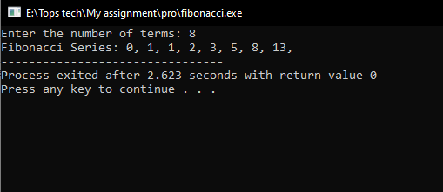

* WAP to print number in reverse order e.g.: number = 64728 ---> reverse = 82746

INPUT

|  |
| --- |
| #include <stdio.h>  int main(){  int num,r,sum=0,t;  printf("Input a number: ");  scanf("%d",&num);  for(t=num;num!=0;num=num/10){  r=num % 10;  sum=sum*10+r;  }  printf("The number in reverse order is : %d \n",sum);  } |

OUTPUT

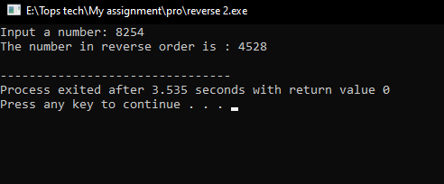

* Write a program make a summation of given number (E.g., 1523 Ans: -11)

INPUT

|  |
| --- |
| #include <stdio.h>  int main(){  int num,r,sum=0,t;  printf("Input a number: ");  scanf("%d",&num);  for(t=num;num!=0;num=num/10){  r=num % 10;  sum = sum+r;  }  printf("The number in reverse order is : %d \n",sum);  } |

OUTPUT

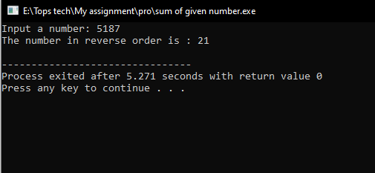

* Patterns:

1 ) INPUT

|  |
| --- |
| #include<stdio.h>  int main()  {  int i,j,c = 1;  for(i=1;i<=5;i++)  {  for(j=1;j<=i;j++)  {  printf("%d ",c%2);  c++;  }  c = 1;  printf("\n");  }  return 0;  } |

OUTPUT

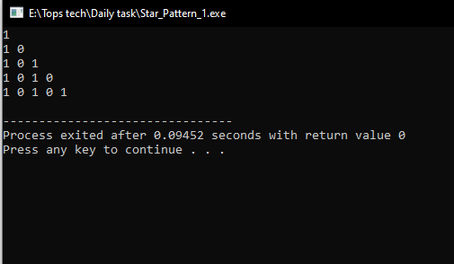

2 ) INPUT

|  |
| --- |
| #include<stdio.h>  int main()  {  int i,j;  char a = 'A';  for(i=1;i<=5;i++)  {  for(j=1;j<=i;j++)  {  printf("%c ",a);  a++;  }  printf("\n");  }  return 0;  } |

OUTPUT

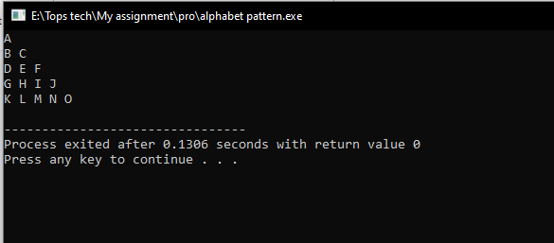

3 ) INPUT

|  |
| --- |
| #include<stdio.h>  int main()  {  int i,j,k;  for(i=1;i<=5;i++)  {  for(j=5;j>=i;j--)  {  printf(" ");  }  for(k=1;k<=i;k++)  {  printf("* ");  }  printf("\n");  }  return 0;  } |

OUTPUT

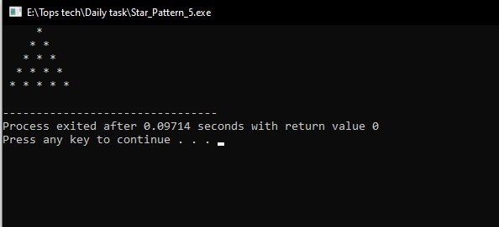

4 ) INPUT

|  |
| --- |
| #include<stdio.h>  int main()  {  int i,j,c = 1;  for(i=1;i<=5;i++)  {  for(j=1;j<=i;j++)  {  printf("* ");  }  printf("\n");  }  for(i=1;i<=5;i++)  {  for(j=5;j>=i;j--)  {  printf("* ");  }  printf("\n");  }  return 0;  } |

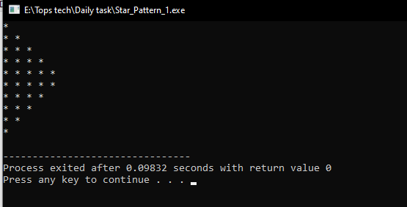 OUTPUT

5 ) INPUT

|  |
| --- |
| #include<stdio.h>  int main()  {  int i,j;  char a ='A';  for(i=1;i<=5;i++)  {  for(j=1;j<=i;j++)  {  printf("%c ",a);  a++;  }  a = 'A';  printf("\n");  }  return 0;  } |

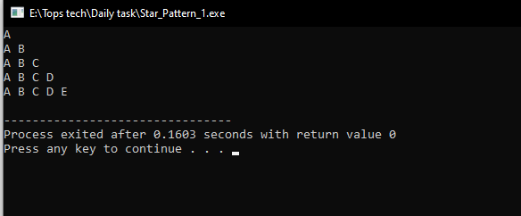 OUTPUT

6 ) INPUT

|  |
| --- |
| #include<stdio.h>  int main()  {  int i,j;  int a =1;  for(i=1;i<=5;i++)  {  for(j=1;j<=i;j++)  {  printf("%d ",a);  a++;  }  printf("\n");  }  return 0;  } |

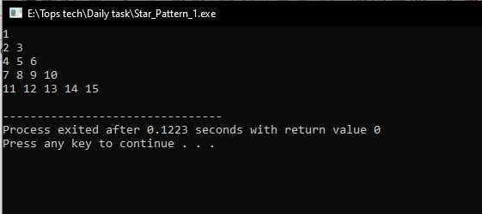 OUTPUT

* Write a program to find out the max number from given array using function

INPUT

|  |
| --- |
| #include <stdio.h>    int main()  {  int arr[] = {25, 11, 7, 75, 56};  int length = sizeof(arr)/sizeof(arr[0]);  int max = arr[0];  for (int i = 0; i < length; i++) {  printf("The array element %d is : %d \n",i,arr[i] );  }  for (int i = 0; i < length; i++) {  if(arr[i] > max)  max = arr[i];  }  printf("\nLargest element present in given array: %d\n", max);  return 0;  } |

OUTPUT

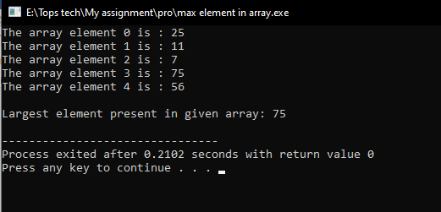

* WAP of Addition, Subtraction, Multiplication and Division using Switch case.(Must Be Menu Driven)

INPUT

|  |
| --- |
| #include<stdio.h>    int main()  {  int a, b;  char choice;  printf("a. Addition\nb. Subtraction\nc. Multiplication\nd. Division\n");  printf("\nEnter your choice\n");  scanf("%c", &choice);  printf("Enter 2 integer numbers\n");  scanf("%d %d", &a, &b);  switch(choice)  {  case 'a': printf("%d + %d = %d\n", a, b, (a+b));  break;    case 'b': printf("%d - %d = %d\n", a, b, (a-b));  break;    case 'c': printf("%d x %d = %d\n", a, b, (a*b));  break;    case 'd': if( b != 0)  printf("%d / %d = %d\n", a, b, (a/b));  else  printf("Number can't be divided by 0\n");  break;    default: printf("You entered wrong choice\n");  break;  }  return 0;  } |

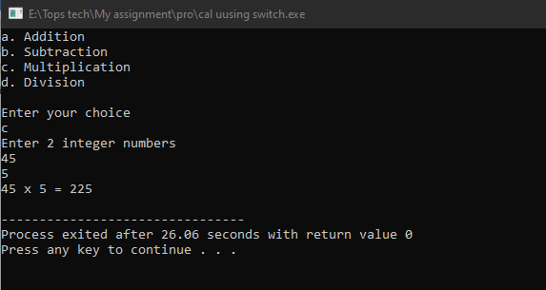 OUTPUT

* WAP to find reverse of string using recursion

INPUT

|  |
| --- |
| #include <stdio.h>  #include <string.h>    void revstr(char *str1)  {  static int i, len, temp;  len = strlen(str1);    if (i < len/2){  temp = str1[i];  str1[i] = str1[len - i - 1];  str1[len - i - 1] = temp;  i++;  revstr(str1);  }  }    int main()  {  char str1[50];  printf (" Enter the string: ");  gets(str1);  printf (" \n Before reversing the string: %s \n", str1);    revstr(str1);  printf (" After reversing the string: %s", str1);  } |

OUTPUT

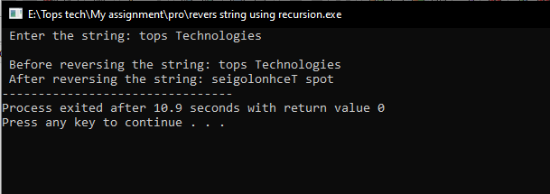

* WAP to find factorial using recursion

INPUT

|  |
| --- |
| #include<stdio.h>    int factorial(int n)  {  if (n == 0)  return 1;  else  return(n * factorial(n-1));  }    int main()  {  int number;  long fact;  printf("Enter a number: ");  scanf("%d", &number);    fact = factorial(number);  printf("Factorial of %d is %ld\n", number, fact);  return 0;  } |

OUTPUT

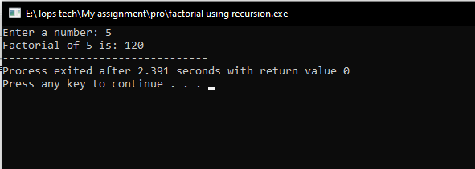

* WAP to take two Array input from user and sort them in ascending or descending order as per user’s choice

INPUT

|  |
| --- |
| #include <stdio.h>  int main()  {  int i, j, a, number[30],n;  for (i = 0; i < 5; ++i){  printf("Enter the %d numbers :",i);  scanf("%d", &number[i]);  }  printf("\nENTER 1 To Sort Array In Ascending Order ");  printf("\nENTER 2 To Sort Array In Descending Order ");  printf("\nEnter Your choise : ");  scanf("%d",&n);  if(n==1)  {  for (i = 0; i < 5; ++i)  {  for (j = i + 1; j < 5; ++j)  {    if (number[i] > number[j])  {  a = number[i];  number[i] = number[j];  number[j] = a;  }    }  }  printf("\nThe numbers arranged in ascending order are given below \n");  for (i = 0; i < 5; ++i)  {  printf("%d\n", number[i]);  }  }  else if(n==2)  {  for (i = 0; i < 5; ++i)  {  for (j = i + 1; j < 5; ++j)  {    if (number[i] < number[j])  {    a = number[i];  number[i] = number[j];  number[j] = a;    }    }    }  printf("\nThe numbers arranged in descending order are given below \n");  for (i = 0; i < 5; ++i)  {  printf("%d\n", number[i]);  }  }  else  {  printf("Enter valid input");  }    } |

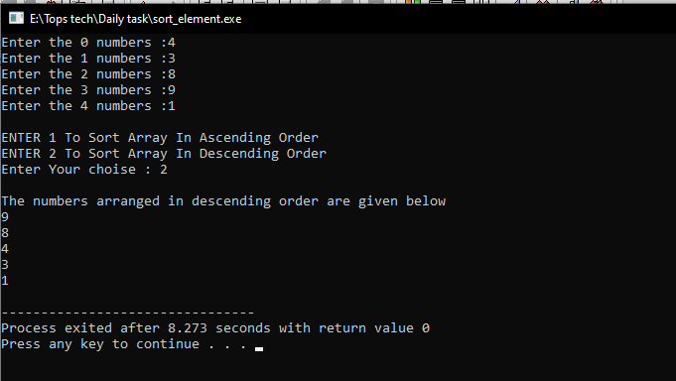 OUTPUT

* WAP to make addition, Subtraction and multiplication of two matrix using 2-D Array

INPUT

|  |
| --- |
| #include<stdio.h>  int main()  {  printf("----------Enter First Matrix element------------\n\n");  int a[2][2],b[2][2];  for (int i = 0 ; i < 2 ; i++)  {  for(int j = 0 ; j < 2 ; j++)  {  printf("Enter [%d] [%d] element : ",i,j);  scanf("%d",a[i][j]);  printf("\n");  }  }  printf("----------Enter Second Matrix element------------\n\n");  for (int i = 0 ; i < 2 ; i++)  {  for(int j = 0 ; j < 2 ; j++)  {  printf("Enter [%d] [%d] element : ",i,j);  scanf("%d",b[i][j]);  printf("\n");  }  }  printf("----------Addition Of Matrix------------\n\n");  int add[2][2];  for (int i = 0 ; i < 2 ; i++)  {  for(int j = 0 ; j < 2 ; j++)  {  add[i][j] = b[i][j]+a[i][j];  }  }  for (int i = 0 ; i < 2 ; i++)  {  for(int j = 0 ; j < 2 ; j++)  {  printf("%d ",add[i][j]);  }  printf("\n");  }  printf("----------Multiplication Of Matrix------------\n\n");  int mul[2][2];  for (int i = 0 ; i < 2 ; i++)  {  for(int j = 0 ; j < 2 ; j++)  {  mul[i][j] = 0;  for(int k = 0 ; k < 2 ; k ++)  {  mul[i][j] = mul[i][j]+a[i][k]*b[k][j];  }  }  }  for (int i = 0 ; i < 2 ; i++)  {  for(int j = 0 ; j < 2 ; j++)  {  printf("%d ",add[i][j]);  }  printf("\n");  }  } |

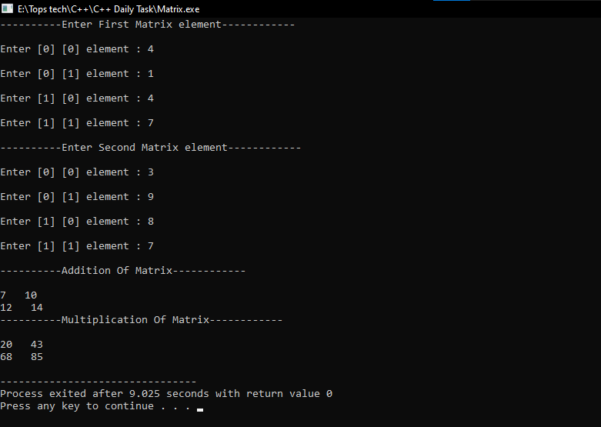 OUTP

* WAP Find out length of string without using inbuilt function

INPUT

|  |
| --- |
| #include<stdio.h>  int main()  {  char a[50];  printf("Enter String : ");  scanf("%s",&a);  int c=0,i;  for(i=0; a[i]!='\0'; i++)  {  c++;  }  printf("\nThe length of string : %d ",c);    } |

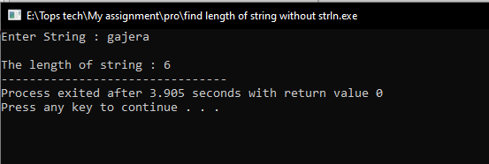 OUTPUT

* WAP to reverse a string and check that the string is palindrome or not

INPUT

|  |
| --- |
| #include <stdio.h>  #include <string.h>  int main(){  char string1[20];  int i, length;  int flag = 0;    printf("Enter a string:");  scanf("%s", string1);    length = strlen(string1);    for(i=0;i < length ;i++){  if(string1[i] != string1[length-i-1]){  flag = 1;  break;  }  }    if (flag) {  printf("%s is not a palindrome", string1);  }  else {  printf("%s is a palindrome", string1);  }  return 0;  } |

OUTPUT

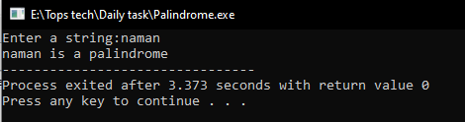

* Write a program of structure for five employee that provides the following information -print and display empno, empname, address and age

INPUT

|  |
| --- |
| #include <stdio.h>  #include <stdlib.h>    typedef struct{  int id;  char name[30];  int age;  char city[30];  } Employee;    int main()  {  int n=5;  Employee employees[n];  printf("Enter %d Employee Details \n \n",n);  for(int i=0; i<n; i++){  printf("Employee %d:- \n",i+1);  printf("Id : ");  scanf("%d",&employees[i].id);  printf("Name : ");  scanf("%s",employees[i].name);  printf("Age : ");  scanf("%d",&employees[i].age);  printf("City : ");  scanf("%s",&employees[i].city);  char ch = getchar();    printf("\n");  }  printf("-------------- All Employees Details ---------------\n");  for(int i=0; i<5; i++){  printf("Id \t: ");  printf("%d \n",employees[i].id);  printf("Name \t: ");  printf("%s \n",employees[i].name);  printf("Age \t: ");  printf("%d \n",employees[i].age);  printf("City \t: ");  printf("%s",employees[i].city);  printf("\n");  }  return 0;  } |

OUTPUT

